Alg 1 Night School Name: ____________________________

____________ ____________
WS Assessment

Target 4:
modeling linear

I can :
- Model a linear function (in table, graph, rule and situation)

Standard: A2. Linear Functions
● A2a. I can model a linear function (in a table, graph, rule & situation).
● A2b. I can determine the equation of a line.

Data – Table – Rule
1. Fill in the table and write the rule

2. Draw Figure 1 and Figure 5

Figure 1 Figure 5
Describe how Figure 100 look like?

Figure 1 Figure 5
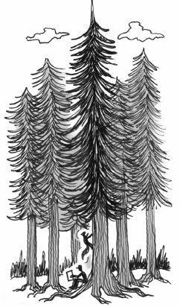
Describe how Figure 100 look like?

3. John found the data in the table about his favorite redwood tree. He wondered if he could use it to predict the height of the tree at other points of time.
Consider this as you analyze the data and answer the
questions below.
a. How tall was the tree 2 years after it was planted? ____ What about 7 years after ? _______
b. How tall was the tree the year it was planted? _______ How about 50 years after ?________
c. Find the equation of this tree. Show me the graph and table on the calculator for stamp
I want to see how the tree grow for 50 years (x from 0 to 50)

Stamp _____________
4.

Figure 0 Figure 4
Fill in the following
Table Graph Equation
 | 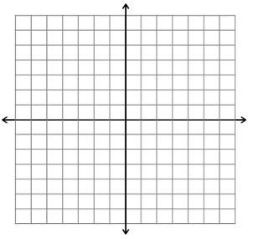 | y = ___________________  What is the domain and range?  (Condition of x and y)
  x | y
  0
  1
  2
  3
  4

5. Complete the table and write the equation
y = _______________________________________
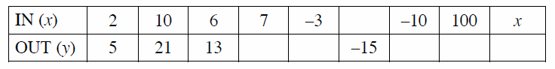
y = _______________________________________

6. Coordinator on graph

Multiple Representation
Each group of 4 choose 1 different set. Stamp
On the poster paper, you should show
a. The data (Figure 0, 1, 2, 3, 4)
b. The table (x – y )
c. The equation
d. The graph
and the description how Figure 100 look like. Make sure each of you get a stamp after done the poster.
Now without team, do it yourself. Remember you should show
a. The data (Figure 0, 1, 2, 3, 4)
b. The table (x – y )
c. The equation
d. The graph
and the description how Figure 100 look like.

Figure 0 Figure 4

Assessment Target 4 Name:_______________________ Date: __________
I can… model a linear function (in a table, graph, rule & situation).

1. Fill in

Figure 0 Figure 4

Describe Figure 100 in detail

2. Write the equation of the perimeter and area for this dented square
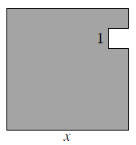
Perimeter P =

Area A =

If given x = 32 what is the Perimeter and Area? __________________

3.

4. Complete the table and write the equation
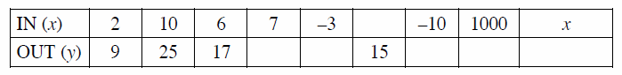
y = ______________

5. Given the situation below, draw 2 more Figures of your choice for each.
a. b.

